AUTOMOBILE MANAGEMENT SYSTEM

MINI PROJECT REPORT

Submitted by

KALAIYARASAN S | REG.NO:18TD0633
DANIEL MARTEL A | REG.NO: 18TD0616
ARAVIND KUMAR S | REG.NO: 18TD0603

In partial fulfillment of the requirement for the award of the Degree of
BACHELOR OF TECHNOLOGY
IN
COMPUTER SCIENCE AND ENGINEERING
PONDICHERRY UNIVERSITY


DEPARTMENT OF COMPUTER SCIENCE AND ENGINEERING
MANAKULA VINAYAGAR INSTITUTE OF TECHNOLOGY
KALITHEERTHALKUPPAM, PUDUCHERRY - 605 107.
FEBRUARY – 2021

MANAKULA VINAYAGAR INSTITUTE OF TECHNOLOGY

DEPARTMENT OF COMPUTER SCIENCE AND ENGINEERING

BONAFIDE CERTIFICATE

This is to certify that the Mini Project Work titled “AUTOMOBILE MANAGEMENT SYSTEM” is a bonafide work done by KALAIYARASAN S [REGISTER NO: 1T8D0633], DANIEL MARTEL A [REGISTER NO: 18TD0616] and ARAVIND KUMAR S [REGISTER NO: 18TD0603] in partial fulfillment for the award of the degree of Bachelor of Technology in Computer Science Engineering of the Pondicherry University during the academic year 2020-21.

Mr. S. ASHOK KUMAR  Assistant Professor  Department of CSE | Dr. S.PARISELVAM  Professor/ Head of Department  Department of CSE

ACKNOWLEDGEMENT
I am personally indebted to a number of persons that a complete acknowledgement would be encyclopedic. First of all, I love to record my deepest gratitude to the Almighty Lord and my family.
I express my sincere and heartfelt thanks to our Chairman and Managing Director Shri. M. DHANASEKARAN for all his encouragement and moral support. I also thank our Vice Chairman Shri. S. V. SUGUMARAN and our Secretary Dr. K. NARAYANASAMY for his support and encouragement.
It gives me great ecstasy of pleasure to convey my deep and sincere thanks to our Principal Dr. S. MALARKKAN, for giving constant motivation in succeeding my goal. With profoundness I would like to express my sincere thanks to our beloved Head of the Department, Dr. S. PARISELVAM, Professor, Computer Science and Engineering, for his kindness in extending the infrastructural facilities to carry out my project work successfully.
I extend my sincere gratitude and heartfelt thanks to our staff co-ordinator Mr. S. ASHOK KUMAR, Assistant Professor, Computer Science and Engineering, for providing the right ambience for carrying out this work and his valuable guidance and suggestions for our work. I thank him, for the continuous encouragement and the interest shown to bring out our work at this stage and also for providing the freedom that I needed and wanted.
I would like to express my gratitude to all teaching and non-teaching staff members of our Department for the support they extended during the course of this project.

ABSTRACT

Vehicle Management System has three types of users Manager [Admin] and Users. There is only one Admin in this software. The software is intended to do two major tasks i.e. Booking Management and Fleet Management. Booking Management keeps track of all the vehicle bookings related transactions. It includes New Vehicle Registration, Listing Vehicles, Checking Availability, Booking Vehicles, Booking Cancellation, Fare Calculation, Booking History. While Fleet Management keeps track of vehicles. It includes Repair and Maintenance Logs, Fuel Logs, Lubricant Logs, Distance Logs, Parts Changed Records and Vehicle Ratings. It also keep track of expenses and bills of the company. Daily Reports can be generated on the basis of these input data collected by Bookings and Fleet Management Modules. User may also print these details if he wants to. It has a Feedback Module where customers of the company can give their feedbacks. A customer can also Rate a vehicle if he had booked it in past. Different types of users have different privileges to the software. Admin has the maximum access to the software.

TABLE OF CONTENTS

CHAPTER NO | TITLE | PAGE NO
 | ACKNOWLEDGEMENT | i
 | ABSTRACT | ii
 | TABLE OF CONTENTS | iii
1 | INTRODUCTION | 1
 | 1.1 Overview | 1
 | 1.2 Objective | 2
 | 1.2.1 Scope Of The Project. | 3
 |  | 7
2 | Block Diagram. | 8
3 | Hardware & Software Requirements. | 12
 | 3.1 Codes & Output. | 12
 |  | 30
4 | CONCLUSION | 32

1. INTRODUCTION:
- Vehicle Management System is a windows application which aims to minimize the effort put in company to maintain their transactions.
- It manages all the transactions related to Vehicle profiling, Vehicle Bookings, Fleet management, Booking Details, Daily Expenses, Daily Reports and Customer Feedbacks of the company.
- This system also provides a magical way of dealing with problem of employee attendance and calculating various aspects regarding the employee salary.
- At any time, Administrator or Director of the company can determine the progress of any department with the help of this system.As the current trend is of competition age, so that timely and up to date report generation is a very important for any business organization.
- Through these reports the director of the company can better understand the current status of their organization. So that he can better decide what new strategy should be opt.
- The service department manages all type of service records. The task performed during the service of any bajaj vehicle are as follows,
1. Vehicle details, which has to be serviced.
2. Accessories or Parts details to be maintained during servicing.
3. Generation of Service bill.
- In Login Page, enter username and password which will be further authenticated and recognize their username as admin, Employee, Driver or User accordingly functional window will open

- In Profile module a admin can add a new users to the database. He can set the details of the staff and the users also, while users and employees will only be able to see their details and update the information in this module. Only admin can add or drop the users.
- In Vehicles modules, all the vehicles are listed there. Every user has the privilege to add vehicles and all of them can view the available vehicle. They can also book the available vehicles from there but only admin can delete vehicles from the list.
- In Fleet Management module, Only staff and admin has the privilege to access it. It contains all the information related to the vehicles their distance monitoring, Fuel consumptions, Present Location, Repair and Maintenance records and upcoming schedules and history of parts changed. It also includes the vehicle tracking privileged only to the admin.
- Booking charts will provide you with the list of booked seats with customer ID, customer name & contact number in case he/she is late.
- In Expenses, employees and drivers will enter expenses like petrol expenses, electricity bills, etc.
- Reports will organize data logs based on uploaded bills and expenses entered by Admin and employees. Admin can view all logs as expenses, fuel, distance and can also print & save the logs. These are generated on daily basis.
- Admin will be able to see/check all the submitted/uploaded bills by the employees & drivers w.r.t dates. and employees & drivers have to upload bills for any reported expenses by them .
- And also they can see all bills submitted by themselves. All these details can be seen in Reports module of the software.
- Feedback module is used to get feedbacks from the users and admin is able to view the feedbacks submitted by different user.
- The User Requirements Specification describes the needs for what users require from the system.
- User Requirements Specifications are written early in the validation process, typically before the system is created.
- They are written by the system owner and end-users, with input from Quality Assurance.
- Requirements outlined in the URS are usually tested in the Performance Qualification or User Acceptance Testing.
- User Requirements Specifications are not intended to be a technical document; readers with only a general knowledge of the system should be able to understand the requirements outlined in the URS.
- This application mainly concentrated about the transport. The admin user can view the details of all the categories of the transport.
- This categories viewing list has shows the ID Number of the category, category code, how much amount per month, and how much distance allotted for the particular category, all these information will be provided.
- The administrator can add the vehicle depends upon the situation of the company.
- The admin user can view the details of all the routes. In this routes module the admin user can view the pickup points of the particular route.
- He can add or remove the pickup points of the route. He can view the details of all the vehicle requests which are posted from the employees.
- If he needs the transport facility, then he can also apply the vehicle request. He can add or remove the vehicles.
- He can view the details of all the vehicle requests of the employees.
- The user can view the details of all the vehicles. He can view the details of all the routes.
- The transport user can view the details of all the vehicle requests which are posted from the employees of the company.
- After his careful verification only he can provide the transport facility to the requested employee. He can add or remove the request of the employee.
- Nonfunctional requirements are the properties that your product must have. Think of these properties as the characteristics or qualities that make the product attractive, or usable, or fast, or reliable.
- These properties are not required because they are fundamental activities of the product -- activities such as computations, manipulating data, and so on -- but are there because the client wants the fundamental activities to perform in a certain manner.
- They are not part of the fundamental reason for the product's existence, but are needed to make the product perform in the desired manner.

1.1 OVERVIEW:
There are basically 8 forms in this software:

- Login/Registration ,
  - ADMIN:
    - View/Edit/Delete Vehicle Details
    - View/Edit/Delete User Details
    - Add New User/Employee/Driver
    - Book Vehicle
    - Booking History
    - Booking Status Detail
    - View Booking Charts
  - USER MODULE:
    - Login/Registration of User
    - View and Update User Profile
    - View Vehicle Details
    - Book Vehicle
    - Booking History
    - Give Feedback
- Profiles,
  - Admin.
  - Customer.
- Vehicles ,
  - Cars
  - Bikes
- Booking Management,
- Fleet Management,
- Expenses ,
- Reports ,
- Feedback.

1.2 OBJECTIVE:
The objective of the proposed system is to create a more sophisticated and user-friendly working environment for the three pillars of the company namely sales, service and parts departments. The proposed system optimize the time spend in the activities, performed during the sale, service of any vehicle and selling or purchasing of parts. Proper management of sale data and accurate report generation are the factors, responsible for the growth of any business body.
The objective of this system can be summarized as,
“To provide a such kind of platform where the company can increase their growth and market strength through the optimization in time and man power with the help of proposed system. Also the company can better target to their goals through the various types of reports and charts generated by the system.
1. The aim of this application is to reduce the manual effort needed to manage transactions in a company.
2. Application provides an interface to users to view the details like the Trans Vehicle details, Vehicle Booking, Profile Management, Repair and Maintenance schedules, Expenses Details, Daily Reports and Feedbacks.
3. Increases the profitability of the company by reducing the cost to purchase different software for different tasks to be performed.

1.2.1 SCOPE OF THE PROJECT:
- To register and keep the information about all vehicles.
- To build up a system that provides and generates the summary
- Report from the database records in order to get the whole view about the vehicles amounts.
- Summarize the accidental records and responds for the further improvements.
- A web based tool where user can search for additional information of the vehicle.
2. BLOCK DIAGRAM:
Data Flow Diagram:
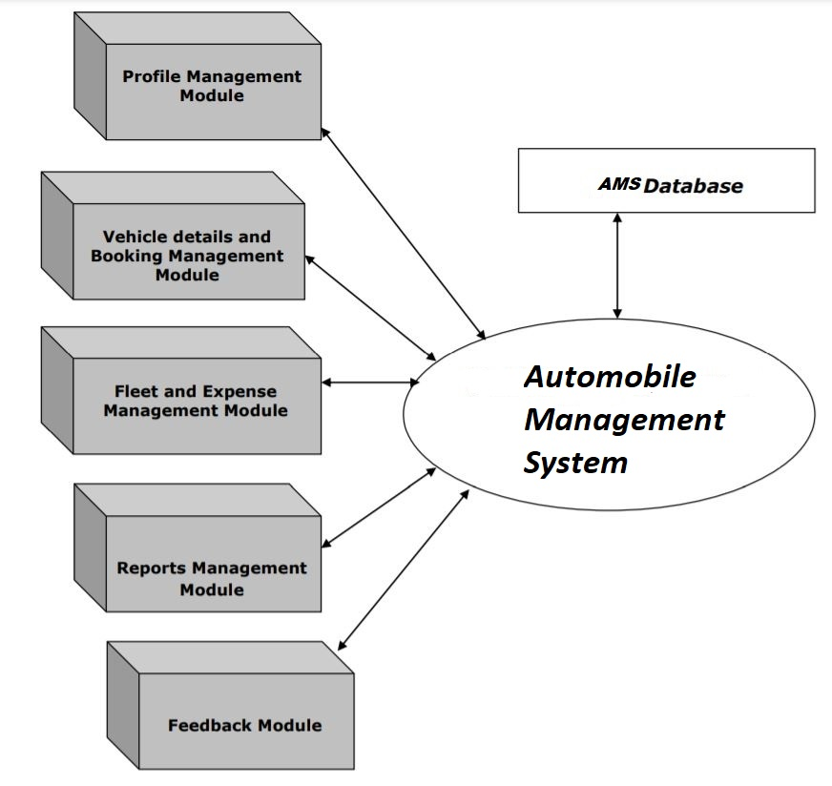

Use Case Diagram:
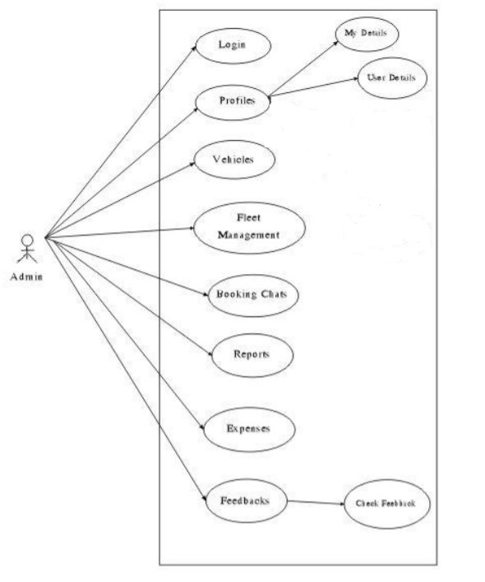
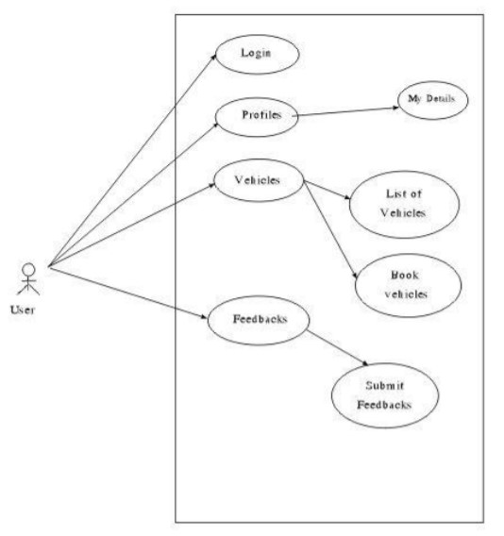

Class Diagram:
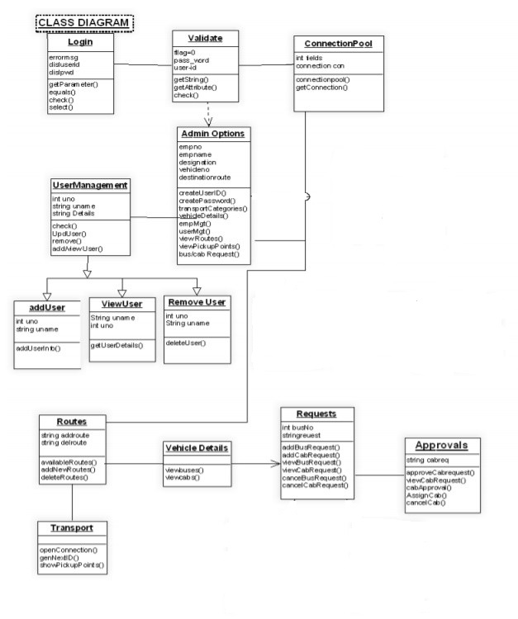

3. Hardware & Software Requirements:
HARDWARE REQUIREMENTS:
The minimum requirements needed to perform operations are
• Intel Pentium Processor at 2 GHz or Higher
• RAM 256MB or more
• Hard disk capacity 10GB or more

SOFTWARE REQUIREMENTS:
The software required to perform the implementation are
• Windows Operating System.
• Visual Studio
• Notepad++
• XAMPP
• HTML
TOOLS:
XAMPP.
FRONTEND:
HTML, JAVASCRIPT, CSS.
BACKEND:
PHP, MYSQL.
DATABASE:
MYSQL.

3.1 Codes & Output:
Automobile Management System Website:
Home Page:

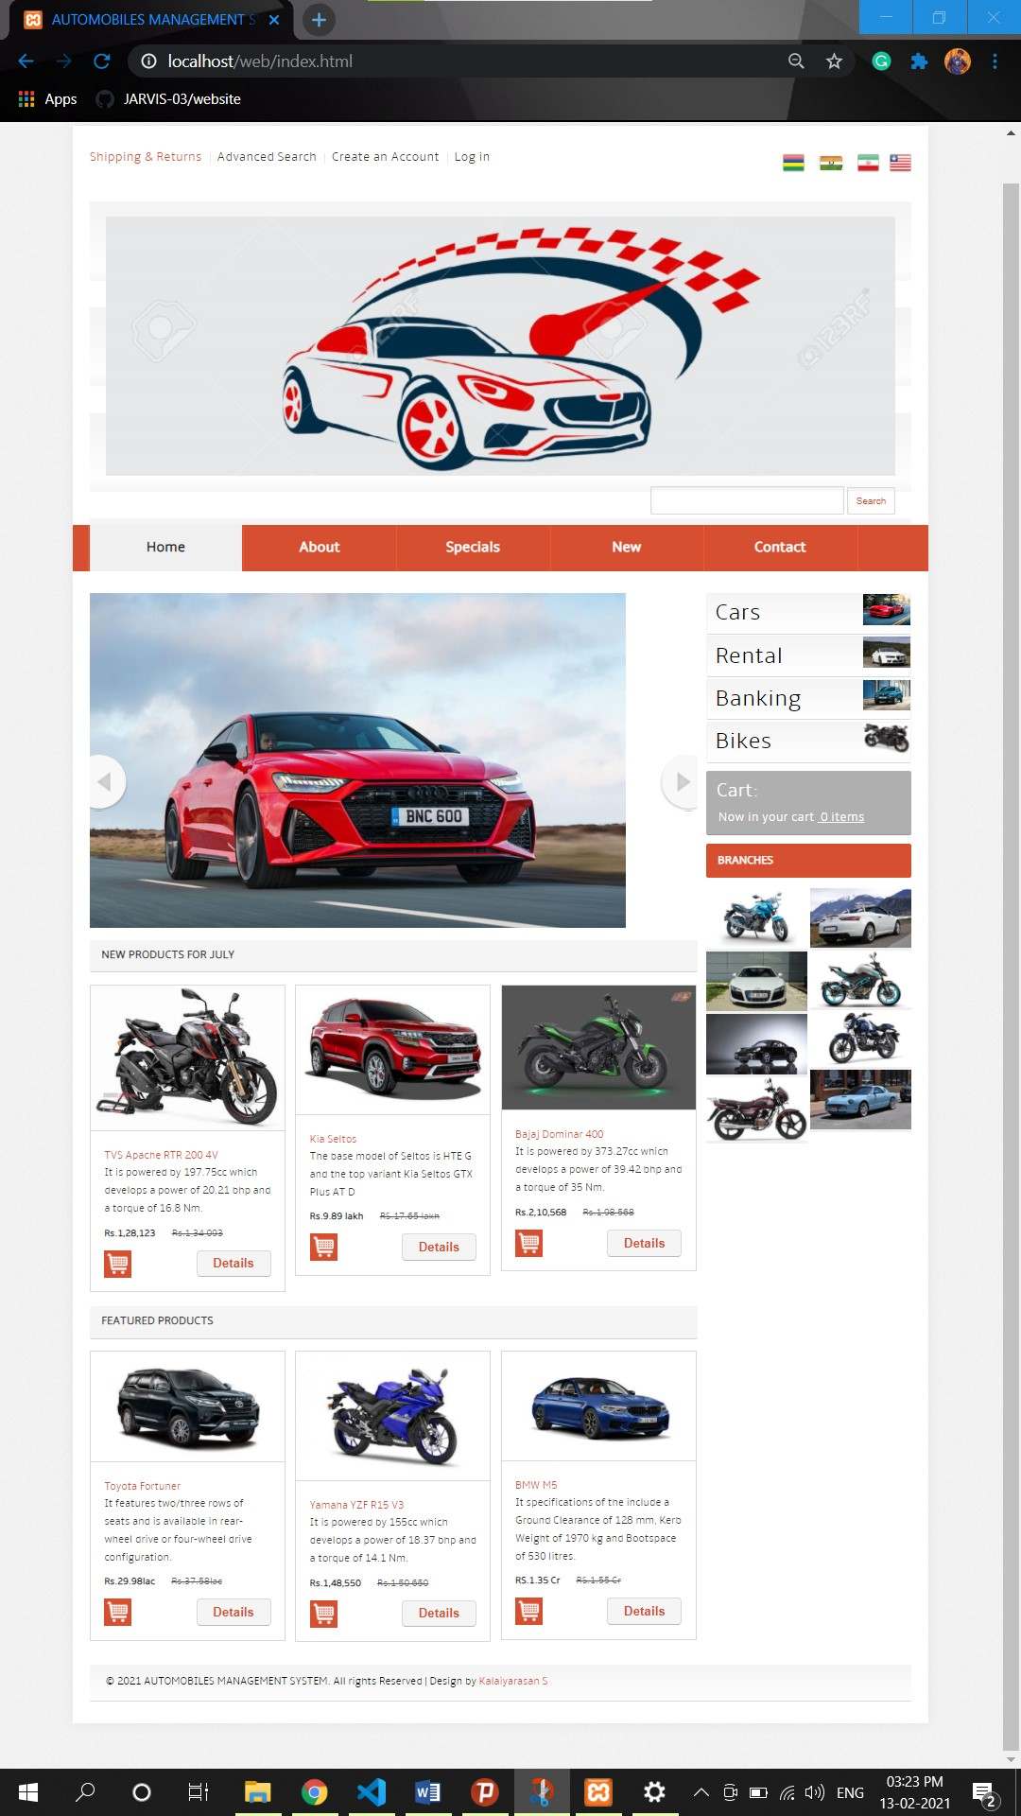

Home Page Code:
<!DOCTYPE HTML>
<html>
<head>
<title>AUTOMOBILES MANAGEMENT SYSTEM | Home :: SKY INDUSTRIES</title>
<link href="css/style.css" rel="stylesheet" type="text/css" media="all" />
<meta name="viewport" content="width=device-width, initial-scale=1, maximum-scale=1">
<meta http-equiv="Content-Type" content="text/html; charset=utf-8" />
<link href='//fonts.googleapis.com/css?family=Playball' rel='stylesheet' type='text/css'>
<!--slider-->
<script src="js/jquery.min.js"></script>
<script src="js/script.js" type="text/javascript"></script>
</head>
<body>
<div class="header-bg">
<div class="wrap">
<div class="h-bg">
<div class="total">
<div class="header">
<div class="box_header_user_menu">
<ul class="user_menu"><li class="act first"><a href="#"><div class="button-t"><span>Shipping &amp; Returns</span></div></a></li><li class=""><a href="#"><div class="button-t"><span>Advanced Search</span></div></a></li>
<li class="">
<div class="button-t"><span><a href="/web/Responsive Registration Form/index.html">Create an Account</a></span></div></li>
<li class="last"><a href="/web/login.html"><div class="button-t"><span>Log in</span></div></a></li></ul>
</div>
<div class="header-right">
<ul class="follow_icon">
<li><a href="#"><img src="images/icon.png" alt=""/></a></li>
<li><a href="#"><img src="images/icon1.png" alt=""/></a></li>
<li><a href="#"><img src="images/icon2.png" alt=""/></a></li>
<li><a href="#"><img src="images/icon3.png" alt=""/></a></li>
</ul>
</div><div class="clear"></div>
<div class="header-bot">
<div class="logo">
<a href="index.html"><img src="images/logo.jpg" alt=""/></a>
</div>
<div class="search">
<input type="text" class="textbox" value="" onfocus="this.value = '';" onblur="if (this.value == '') {this.value = '';}">
<button class="gray-button"><span>Search</span></button>
</div>
<div class="clear"></div>
</div>
</div>
<div class="menu">
<div class="top-nav">
<ul>
<li class="active"><a href="index.html">Home</a></li>
<li><a href="about.html">About</a></li>
<li><a href="specials.html">Specials</a></li>
<li><a href="new.html">New</a></li>
<li><a href="contact.html">Contact</a></li>
</ul>
<div class="clear"></div>
</div>
</div>
<div class="banner-top">
<div class="header-bottom">
<div class="header_bottom_right_images">
<div id="slideshow">
<ul class="slides">
<li><a href="details.html"><canvas ></canvas><img src="images/banner4.jpg" alt="Marsa Alam underawter close up" ></a></li>
<li><a href="details.html"><canvas></canvas><img src="images/banner2.jpg" alt="Turrimetta Beach - Dawn" ></a></li>
<li><a href="details.html"><canvas></canvas><img src="images/banner3.jpg" alt="Power Station" ></a></li>
<li><a href="details.html"><canvas></canvas><img src="images/banner1.jpg" alt="Colors of Nature" ></a></li>
</ul>
<span class="arrow previous"></span>
<span class="arrow next"></span>
</div>
<div class="content-wrapper">
<div class="content-top">
<div class="box_wrapper"><h1>New Products For July</h1>
</div>
<div class="text">
<div class="grid_1_of_3 images_1_of_3">
<div class="grid_1">
<a href="single.html"><img src="images/pic5.jpg" title="continue reading" alt=""></a>
<div class="grid_desc">
<p class="title">TVS Apache RTR 200 4V</p>
<p class="title1">It is powered by 197.75cc which develops a power of 20.21 bhp and a torque of 16.8 Nm.</p>
<div class="price" style="height: 19px;">
<span class="reducedfrom">Rs.1,28,123</span>
<span class="actual">Rs.1,34,093</span>
</div>
<div class="cart-button">
<div class="cart">
<a href="#"><img src="images/cart.png" alt=""/></a>
</div>
<button class="button"><span>Details</span></button>
<div class="clear"></div>
</div>
</div>
</div><div class="clear"></div>
</div>
<div class="grid_1_of_3 images_1_of_3">
<div class="grid_1">
<a href="single.html"><img src="images/pic6.jpg" title="continue reading" alt=""></a>
<div class="grid_desc">
<p class="title">Kia Seltos</p>
<p class="title1">The base model of Seltos is HTE G and the top variant Kia Seltos GTX Plus AT D</p>
<div class="price" style="height: 19px;">
<span class="reducedfrom">Rs.9.89 lakh</span>
<span class="actual">RS.17.65 lakh</span>
</div>
<div class="cart-button">
<div class="cart">
<a href="#"><img src="images/cart.png" alt=""/></a>
</div>
<button class="button"><span>Details</span></button>
<div class="clear"></div>
</div>
</div>
</div><div class="clear"></div>
</div>
<div class="grid_1_of_3 images_1_of_3">
<div class="grid_1">
<a href="single.html"><img src="images/pic4.jpg" title="continue reading" alt=""></a>
<div class="grid_desc">
<p class="title">Bajaj Dominar 400</p>
<p class="title1">It is powered by 373.27cc which develops a power of 39.42 bhp and a torque of 35 Nm.</p>
<div class="price" style="height: 19px;">
<span class="reducedfrom">Rs.2,10,568</span>
<span class="actual">Rs.1,98,568</span>
</div>
<div class="cart-button">
<div class="cart">
<a href="#"><img src="images/cart.png" alt=""/></a>
</div>
<button class="button"><span>Details</span></button>
<div class="clear"></div>
</div>
</div>
</div><div class="clear"></div>
</div><div class="clear"></div>
</div>
</div>
<div class="content-top">
<div class="box_wrapper"><h1>Featured Products</h1>
</div>
<div class="text">
<div class="grid_1_of_3 images_1_of_3">
<div class="grid_1">
<a href="single.html"><img src="images/pic1.jpg" title="continue reading" alt=""></a>
<div class="grid_desc">
<p class="title">Toyota Fortuner</p>
<p class="title1">It features two/three rows of seats and is available in rear-wheel drive or four-wheel drive configuration.</p>
<div class="price" style="height: 19px;">
<span class="reducedfrom">Rs.29.98lac</span>
<span class="actual">Rs.37.58lac</span>
</div>
<div class="cart-button">
<div class="cart">
<a href="#"><img src="images/cart.png" alt=""/></a>
</div>
<button class="button"><span>Details</span></button>
<div class="clear"></div>
</div>
</div>
</div><div class="clear"></div>
</div>
<div class="grid_1_of_3 images_1_of_3">
<div class="grid_1">
<a href="single.html"><img src="images/pic2.jpg" title="continue reading" alt=""></a>
<div class="grid_desc">
<p class="title">Yamaha YZF R15 V3</p>
<p class="title1">It is powered by 155cc which develops a power of 18.37 bhp and a torque of 14.1 Nm.</p>
<div class="price" style="height: 19px;">
<span class="reducedfrom">Rs.1,48,550</span>
<span class="actual">Rs.1,50,650</span>
</div>
<div class="cart-button">
<div class="cart">
<a href="#"><img src="images/cart.png" alt=""/></a>
</div>
<button class="button"><span>Details</span></button>
<div class="clear"></div>
</div>
</div>
</div><div class="clear"></div>
</div>
<div class="grid_1_of_3 images_1_of_3">
<div class="grid_1">
<a href="single.html"><img src="images/pic3.jpg" title="continue reading" alt=""></a>
<div class="grid_desc">
<p class="title">BMW M5</p>
<p class="title1">It specifications of the include a Ground Clearance of 128 mm, Kerb Weight of 1970 kg and Bootspace of 530 litres.</p>
<div class="price" style="height: 19px;">
<span class="reducedfrom">RS.1.35 Cr</span>
<span class="actual">RS.1.55 Cr</span>
</div>
<div class="cart-button">
<div class="cart">
<a href="#"><img src="images/cart.png" alt=""/></a>
</div>
<button class="button"><span>Details</span></button>
<div class="clear"></div>
</div>
</div>
</div><div class="clear"></div>
</div><div class="clear"></div>
</div>
</div>
</div>
</div>
<div class="header-para">
<div class="categories">
<div class="list-categories">
<div class="first-list">
<div class="div_2"><a href="#">Cars</a></div>
<div class="div_img">
<img src="images/car1.jpg" alt="Cars" title="Cars" width="60" height="39">
</div><div class="clear"></div>
</div>
<div class="first-list">
<div class="div_2"><a href="#">Rental</a></div>
<div class="div_img">
<img src="images/car2.jpg" alt="Cars" title="Cars" width="60" height="39">
</div><div class="clear"></div>
</div>
<div class="first-list">
<div class="div_2"><a href="#">Banking</a></div>
<div class="div_img">
<img src="images/car3.jpg" alt="Cars" title="Cars" width="60" height="39">
</div><div class="clear"></div>
</div>
<div class="first-list">
<div class="div_2"><a href="#">Bikes</a></div>
<div class="div_img">
<img src="images/car4.jpg" alt="Cars" title="Cars" width="60" height="39">
</div><div class="clear"></div>
</div>
</div>
<div class="box">
<div class="box-heading"><h1><a href="#">Cart:&nbsp;</a></h1></div>
<div class="box-content">
Now in your cart&nbsp;<strong> 0 items</strong>
</div>
</div>
<div class="box-title">
<h1><span class="title-icon"></span><a href="#">Branches</a></h1>
</div>
<div class="section group example">
<div class="col_1_of_2 span_1_of_2">
<img src="images/pic21.jpg" alt=""/>
<img src="images/pic24.jpg" alt=""/>
<img src="images/pic25.jpg" alt=""/>
<img src="images/pic27.jpg" alt=""/>
</div>
<div class="col_1_of_2 span_1_of_2">
<img src="images/pic22.jpg" alt=""/>
<img src="images/pic23.jpg" alt=""/>
<img src="images/pic26.jpg" alt=""/>
<img src="images/pic28.jpg" alt=""/>
</div><div class="clear"></div>
</div>
<div class="clear"></div>
</div>
</div>
<div class="clear"></div>
<div class="footer-bottom">
<div class="copy">
<p>&copy 2021 AUTOMOBILES MANAGEMENT SYSTEM. All rights Reserved | Design by <a href="https://twitter.com/racerboy_ktm">Kalaiyarasan S</a></p>
</div>
</div>
</div>
</div>
</div>
</div>
</div>
</div>
</body>
</html>

About Page:
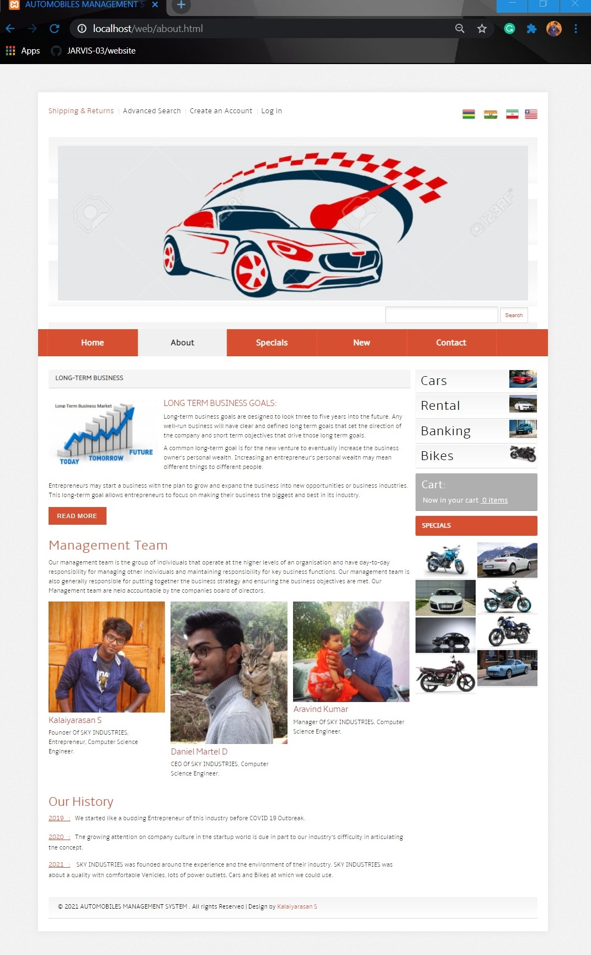

About Page Code:
<!DOCTYPE HTML>
<html>
<head>
<title>AUTOMOBILES MANAGEMENT SYSTEM | About :: SKY INDUSTRIES</title>
<link href="css/style.css" rel="stylesheet" type="text/css" media="all" />
<meta name="viewport" content="width=device-width, initial-scale=1, maximum-scale=1">
<meta http-equiv="Content-Type" content="text/html; charset=utf-8" />
<link href='//fonts.googleapis.com/css?family=Playball' rel='stylesheet' type='text/css'>
</head>
<body>
<div class="header-bg">
<div class="wrap">
<div class="h-bg">
<div class="total">
<div class="header">
<div class="box_header_user_menu">
<ul class="user_menu"><li class="act first"><a href="#"><div class="button-t"><span>Shipping &amp; Returns</span></div></a></li><li class=""><a href="#"><div class="button-t"><span>Advanced Search</span></div></a></li><li class=""><a href="/web/Responsive Registration Form/index.html"><div class="button-t"><span>Create an Account</span></div></a></li><li class="last"><a href="/web/login.html"><div class="button-t"><span>Log in</span></div></a></li></ul>
</div>
<div class="header-right">
<ul class="follow_icon">
<li><a href="#"><img src="images/icon.png" alt=""/></a></li>
<li><a href="#"><img src="images/icon1.png" alt=""/></a></li>
<li><a href="#"><img src="images/icon2.png" alt=""/></a></li>
<li><a href="#"><img src="images/icon3.png" alt=""/></a></li>
</ul>
</div><div class="clear"></div>
<div class="header-bot">
<div class="logo">
<a href="index.html"><img src="images/logo.jpg" alt=""/></a>
</div>
<div class="search">
<input type="text" class="textbox" value="" onfocus="this.value = '';" onblur="if (this.value == '') {this.value = '';}">
<button class="gray-button"><span>Search</span></button>
</div>
<div class="clear"></div>
</div>
</div>
<div class="menu">
<div class="top-nav">
<ul>
<li><a href="index.html">Home</a></li>
<li class="active"><a href="about.html">About</a></li>
<li><a href="specials.html">Specials</a></li>
<li><a href="new.html">New</a></li>
<li><a href="contact.html">Contact</a></li>
</ul>
<div class="clear"></div>
</div>
</div>
<div class="banner-top">
<div class="header-bottom">
<div class="header_bottom_right_images">
<div class="about_wrapper"><h1>Long-Term Business</h1>
</div>
<div class="about-group">
<div class="about-top">
<div class="grid images_3_of_1">
<img src="images/pic7.jpg" alt=""/>
</div>
<div class="grid span_2_of_3">
<h3>LONG TERM BUSINESS GOALS:</h3>
<p>Long-term business goals are designed to look three to five years into the future. Any well-run business will have clear and defined long term goals that set the direction of the company and short term objectives that drive those long term goals.</p>
<p>A common long-term goal is for the new venture to eventually increase the business owner’s personal wealth. Increasing an entrepreneur’s personal wealth may mean different things to different people.</p>
</div><div class="clear"></div>
</div>
<p class="about-para">Entrepreneurs may start a business with the plan to grow and expand the business into new opportunities or business industries. This long-term goal allows entrepreneurs to focus on making their business the biggest and best in its industry.</p><div class="clear"></div>
<button class="btn btn-6 btn-6a">Read More</button>
<div class="team">
<h2>Management Team</h2>
<p>Our management team is the group of individuals that operate at the higher levels of an organisation and have day-to-day responsibility for managing other individuals and maintaining responsibility for key business functions. Our management team is also generally responsible for putting together the business strategy and ensuring the business objectives are met. Our Management team are held accountable by the companies board of directors.</p>
<div class="section group">
<div class="grid_1_of_3 images_1_of_3">
<img src="images/pic8.jpg" alt=""/>
<h3>Kalaiyarasan S</h3>
<p>Founder Of SKY INDUSTRIES, Entrepreneur, Computer Science Engineer.</p>
</div>
<div class="grid_1_of_3 images_1_of_3">
<img src="images/pic9.jpg" alt=""/>
<h3>Daniel Martel D</h3>
<p>CEO Of SKY INDUSTRIES, Computer Science Engineer.</p>
</div>
<div class="grid_1_of_3 images_1_of_3">
<img src="images/pic10.jpg" alt=""/>
<h3>Aravind Kumar </h3>
<p>Manager Of SKY INDUSTRIES, Computer Science Engineer.</p>
</div><div class="clear"></div>
</div>
</div>
<div class="about-bottom">
<div class="grid span_2_of_a">
<h4>Our History</h4>
<ul class="list-2">
<li><span><a href="#">2019&nbsp;&nbsp;&nbsp;:</a>&nbsp;&nbsp;&nbsp;We started like a budding Entrepreneur of this industry before COVID 19 Outbreak.</span></li>
<li><span><a href="#">2020&nbsp;&nbsp;&nbsp;:</a>&nbsp;&nbsp;&nbsp;The growing attention on company culture in the startup world is due in part to our industry’s difficulty in articulating the concept.</span></li>
<li><span><a href="#">2021&nbsp;&nbsp;&nbsp;:</a>&nbsp;&nbsp;&nbsp; SKY INDUSTRIES was founded around the experience and the environment of their industry. SKY INDUSTRIES was about a quality with comfortable Vehicles, lots of power outlets, Cars and Bikes at which we could use.</span></li>
</ul>
</div><div class="clear"></div>
</div>
</div>
</div>
<div class="header-para">
<div class="categories">
<div class="list-categories">
<div class="first-list">
<div class="div_2"><a href="#">Cars</a></div>
<div class="div_img">
<img src="images/car1.jpg" alt="Cars" title="Cars" width="60" height="39">
</div><div class="clear"></div>
</div>
<div class="first-list">
<div class="div_2"><a href="#">Rental</a></div>
<div class="div_img">
<img src="images/car2.jpg" alt="Cars" title="Cars" width="60" height="39">
</div><div class="clear"></div>
</div>
<div class="first-list">
<div class="div_2"><a href="#">Banking</a></div>
<div class="div_img">
<img src="images/car3.jpg" alt="Cars" title="Cars" width="60" height="39">
</div><div class="clear"></div>
</div>
<div class="first-list">
<div class="div_2"><a href="#">Bikes</a></div>
<div class="div_img">
<img src="images/car4.jpg" alt="Cars" title="Cars" width="60" height="39">
</div><div class="clear"></div>
</div>
</div>
<div class="box">
<div class="box-heading"><h1><a href="#">Cart:&nbsp;</a></h1></div>
<div class="box-content">
Now in your cart&nbsp;<strong> 0 items</strong>
</div>
</div>
<div class="box-title">
<h1><span class="title-icon"></span><a href="#">Specials</a></h1>
</div>
<div class="section group example">
<div class="col_1_of_2 span_1_of_2">
<img src="images/pic21.jpg" alt=""/>
<img src="images/pic24.jpg" alt=""/>
<img src="images/pic25.jpg" alt=""/>
<img src="images/pic27.jpg" alt=""/>
</div>
<div class="col_1_of_2 span_1_of_2">
<img src="images/pic22.jpg" alt=""/>
<img src="images/pic23.jpg" alt=""/>
<img src="images/pic26.jpg" alt=""/>
<img src="images/pic28.jpg" alt=""/>
</div><div class="clear"></div>
</div>
</div>
</div>
<div class="clear"></div>
<div class="footer-bottom">
<div class="copy">
<p>&copy 2021 AUTOMOBILES MANAGEMENT SYSTEM . All rights Reserved | Design by <a href="https://twitter.com/racerboy_ktm">Kalaiyarasan S</a></p>
</div>
</div>
</div>
</div>
</div>
</div>
</div>
</div>
</body>
</html>

Special Page:
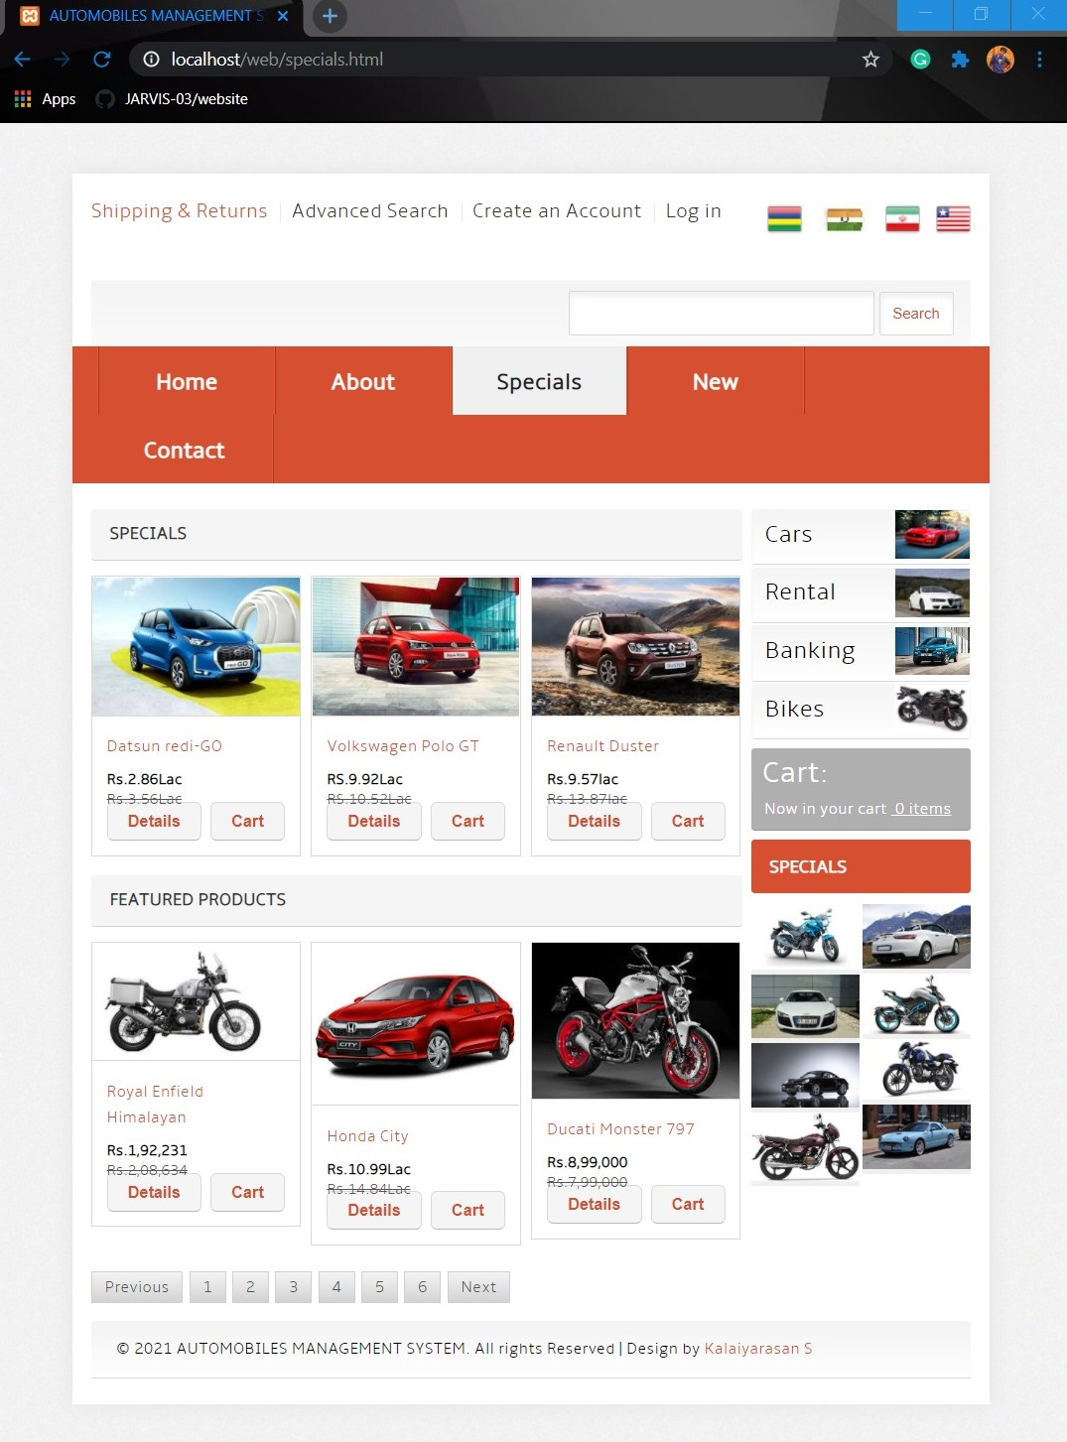

Special Page Code:
<!DOCTYPE HTML>
<html>
<head>
<title>AUTOMOBILES MANAGEMENT SYSTEM | Specials :: SKY INDUSTRIES</title>
<link href="css/style.css" rel="stylesheet" type="text/css" media="all" />
<meta name="viewport" content="width=device-width, initial-scale=1, maximum-scale=1">
<meta http-equiv="Content-Type" content="text/html; charset=utf-8" />
<link href='//fonts.googleapis.com/css?family=Playball' rel='stylesheet' type='text/css'>
</head>
<body>
<div class="header-bg">
<div class="wrap">
<div class="h-bg">
<div class="total">
<div class="header">
<div class="box_header_user_menu">
<ul class="user_menu"><li class="act first"><a href="#"><div class="button-t"><span>Shipping &amp; Returns</span></div></a></li><li class=""><a href="#"><div class="button-t"><span>Advanced Search</span></div></a></li><li class=""><a href="/web/Responsive Registration Form/index.html"><div class="button-t"><span>Create an Account</span></div></a></li><li class="last"><a href="/web/login.html"><div class="button-t"><span>Log in</span></div></a></li></ul>
</div>
<div class="header-right">
<ul class="follow_icon">
<li><a href="#"><img src="images/icon.png" alt=""/></a></li>
<li><a href="#"><img src="images/icon1.png" alt=""/></a></li>
<li><a href="#"><img src="images/icon2.png" alt=""/></a></li>
<li><a href="#"><img src="images/icon3.png" alt=""/></a></li>
</ul>
</div><div class="clear"></div>
<div class="header-bot">
<div class="logo">
<a href="index.html"><img src="images/logo.png" alt=""/></a>
</div>
<div class="search">
<input type="text" class="textbox" value="" onfocus="this.value = '';" onblur="if (this.value == '') {this.value = '';}">
<button class="gray-button"><span>Search</span></button>
</div>
<div class="clear"></div>
</div>
</div>
<div class="menu">
<div class="top-nav">
<ul>
<li><a href="index.html">Home</a></li>
<li><a href="about.html">About</a></li>
<li class="active"><a href="specials.html">Specials</a></li>
<li><a href="new.html">New</a></li>
<li><a href="contact.html">Contact</a></li>
</ul>
<div class="clear"></div>
</div>
</div>
<div class="banner-top">
<div class="header-bottom">
<div class="header_bottom_right_images">

<div class="content-wrapper">
<div class="content-top">
<div class="about_wrapper"><h1>Specials</h1>
</div>
<div class="text">
<div class="grid_1_of_3 images_1_of_3">
<div class="grid_1">
<a href="single.html"><img src="images/pic12.jpg" title="continue reading" alt=""></a>
<div class="grid_desc">
<p class="title">Datsun redi-GO</p>

<div class="price" style="height: 19px;">
<span class="reducedfrom">Rs.2.86Lac</span>
<span class="actual">Rs.3.56Lac</span>
</div>
<div class="cart-button">
<div class="cart">
<button class="button"><span>Details</span></button>
</div>
<button class="button"><span>Cart</span></button>
<div class="clear"></div>
</div>
</div>
</div><div class="clear"></div>
</div>
<div class="grid_1_of_3 images_1_of_3">
<div class="grid_1">
<a href="single.html"><img src="images/pic13.jpg" title="continue reading" alt=""></a>
<div class="grid_desc">
<p class="title">Volkswagen Polo GT</p>

<div class="price" style="height: 19px;">
<span class="reducedfrom">RS.9.92Lac</span>
<span class="actual">RS.10.52Lac</span>
</div>
<div class="cart-button">
<div class="cart">
<button class="button"><span>Details</span></button>
</div>
<button class="button"><span>Cart</span></button>
<div class="clear"></div>
</div>
</div>
</div><div class="clear"></div>
</div>
<div class="grid_1_of_3 images_1_of_3">
<div class="grid_1">
<a href="single.html"><img src="images/pic14.jpg" title="continue reading" alt=""></a>
<div class="grid_desc">
<p class="title">Renault Duster</p>

<div class="price" style="height: 19px;">
<span class="reducedfrom">Rs.9.57lac</span>
<span class="actual">Rs.13.87lac</span>
</div>
<div class="cart-button">
<div class="cart">
<button class="button"><span>Details</span></button>
</div>
<button class="button"><span>Cart</span></button>
<div class="clear"></div>
</div>
</div>
</div><div class="clear"></div>
</div><div class="clear"></div>
</div>
</div>
<div class="content-top">
<div class="box_wrapper"><h1>Featured Products</h1>
</div>
<div class="text">
<div class="grid_1_of_3 images_1_of_3">
<div class="grid_1">
<a href="single.html"><img src="images/pic15.jpg" title="continue reading" alt=""></a>
<div class="grid_desc">
<p class="title">Royal Enfield Himalayan</p>

<div class="price" style="height: 19px;">
<span class="reducedfrom">Rs.1,92,231</span>
<span class="actual">Rs.2,08,634</span>
</div>
<div class="cart-button">
<div class="cart">
<button class="button"><span>Details</span></button>
</div>
<button class="button"><span>Cart</span></button>
<div class="clear"></div>
</div>
</div>
</div><div class="clear"></div>
</div>
<div class="grid_1_of_3 images_1_of_3">
<div class="grid_1">
<a href="single.html"><img src="images/pic16.jpg" title="continue reading" alt=""></a>
<div class="grid_desc">
<p class="title">Honda City</p>

<div class="price" style="height: 19px;">
<span class="reducedfrom">Rs.10.99Lac</span>
<span class="actual">Rs.14.84Lac</span>
</div>
<div class="cart-button">
<div class="cart">
<button class="button"><span>Details</span></button>
</div>
<button class="button"><span>Cart</span></button>
<div class="clear"></div>
</div>
</div>
</div><div class="clear"></div>
</div>
<div class="grid_1_of_3 images_1_of_3">
<div class="grid_1">
<a href="single.html"><img src="images/pic17.jpg" title="continue reading" alt=""></a>
<div class="grid_desc">
<p class="title">Ducati Monster 797</p>

<div class="price" style="height: 19px;">
<span class="reducedfrom">Rs.8,99,000</span>
<span class="actual">Rs.7,99,000</span>
</div>
<div class="cart-button">
<div class="cart">
<button class="button"><span>Details</span></button>
</div>
<button class="button"><span>Cart</span></button>
<div class="clear"></div>
</div>
</div>
</div><div class="clear"></div>
</div><div class="clear"></div>
</div>
</div>
</div>
<div class="paging">
<ul>
<li><a href="#" target="_parent">Previous</a></li>
<li><a href="#" target="_parent">1</a></li>
<li><a href="#" target="_parent">2</a></li>
<li><a href="#" target="_parent">3</a></li>
<li><a href="#" target="_parent">4</a></li>
<li><a href="#" target="_parent">5</a></li>
<li><a href="#" target="_parent">6</a></li>
<li><a href="#" target="_parent">Next</a></li>
</ul>
</div>
</div>
<div class="header-para">
<div class="categories">
<div class="list-categories">
<div class="first-list">
<div class="div_2"><a href="#">Cars</a></div>
<div class="div_img">
<img src="images/car1.jpg" alt="Cars" title="Cars" width="60" height="39">
</div><div class="clear"></div>
</div>
<div class="first-list">
<div class="div_2"><a href="#">Rental</a></div>
<div class="div_img">
<img src="images/car2.jpg" alt="Cars" title="Cars" width="60" height="39">
</div><div class="clear"></div>
</div>
<div class="first-list">
<div class="div_2"><a href="#">Banking</a></div>
<div class="div_img">
<img src="images/car3.jpg" alt="Cars" title="Cars" width="60" height="39">
</div><div class="clear"></div>
</div>
<div class="first-list">
<div class="div_2"><a href="#">Bikes</a></div>
<div class="div_img">
<img src="images/car4.jpg" alt="Cars" title="Cars" width="60" height="39">
</div><div class="clear"></div>
</div>
</div>
<div class="box">
<div class="box-heading"><h1><a href="#">Cart:&nbsp;</a></h1></div>
<div class="box-content">
Now in your cart&nbsp;<strong> 0 items</strong>
</div>
</div>
<div class="box-title">
<h1><span class="title-icon"></span><a href="#">Specials</a></h1>
</div>
<div class="section group example">
<div class="col_1_of_2 span_1_of_2">
<img src="images/pic21.jpg" alt=""/>
<img src="images/pic24.jpg" alt=""/>
<img src="images/pic25.jpg" alt=""/>
<img src="images/pic27.jpg" alt=""/>
</div>
<div class="col_1_of_2 span_1_of_2">
<img src="images/pic22.jpg" alt=""/>
<img src="images/pic23.jpg" alt=""/>
<img src="images/pic26.jpg" alt=""/>
<img src="images/pic28.jpg" alt=""/>
</div><div class="clear"></div>
</div>
</div>
</div><div class="clear"></div>
<div class="footer-bottom">
<div class="copy">
<p>&copy 2021 AUTOMOBILES MANAGEMENT SYSTEM. All rights Reserved | Design by <a href="https://twitter.com/racerboy_ktm">Kalaiyarasan S</a></p>
</div>
</div>
</div>
</div>
</div>
</div>
</div>
</div>
</body>
</html>

Contact Us Page:
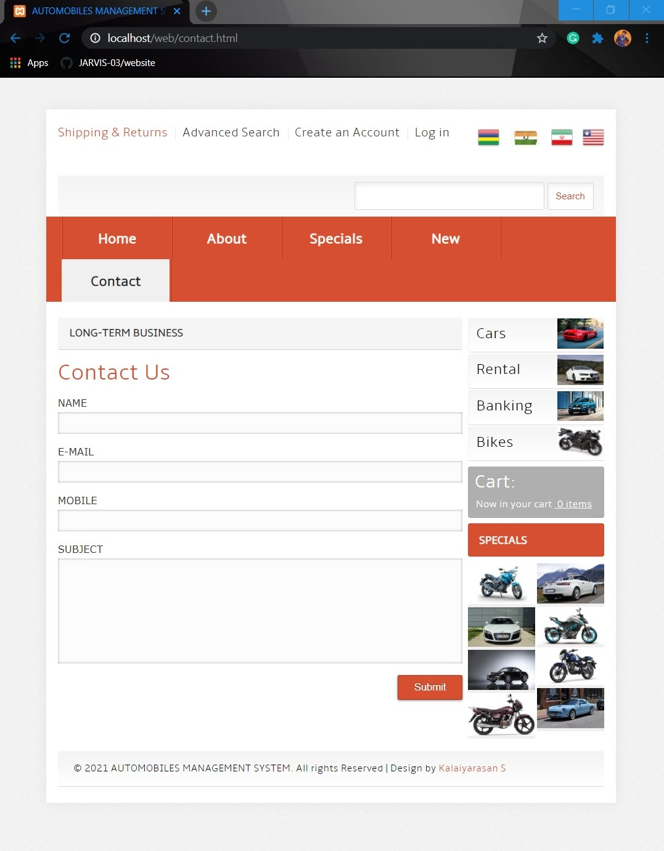

Contact Us Page Code:
<!DOCTYPE HTML>
<html>
<head>
<title>AUTOMOBILES MANAGEMENT SYSTEM | Contact :: SKY INDUSTRIES</title>
<link href="css/style.css" rel="stylesheet" type="text/css" media="all" />
<meta name="viewport" content="width=device-width, initial-scale=1, maximum-scale=1">
<meta http-equiv="Content-Type" content="text/html; charset=utf-8" />
<link href='//fonts.googleapis.com/css?family=Playball' rel='stylesheet' type='text/css'>
</head>
<body>
<div class="header-bg">
<div class="wrap">
<div class="h-bg">
<div class="total">
<div class="header">
<div class="box_header_user_menu">
<ul class="user_menu"><li class="act first"><a href="#"><div class="button-t"><span>Shipping &amp; Returns</span></div></a></li><li class=""><a href="#"><div class="button-t"><span>Advanced Search</span></div></a></li><li class=""><a href="/web/Responsive Registration Form/index.html"><div class="button-t"><span>Create an Account</span></div></a></li>
<li class="last">
<a href="/web/login.html"><div class="button-t"><span>Log in</span></div></a></li></ul>
</div>
<div class="header-right">
<ul class="follow_icon">
<li><a href="#"><img src="images/icon.png" alt=""/></a></li>
<li><a href="#"><img src="images/icon1.png" alt=""/></a></li>
<li><a href="#"><img src="images/icon2.png" alt=""/></a></li>
<li><a href="#"><img src="images/icon3.png" alt=""/></a></li>
</ul>
</div><div class="clear"></div>
<div class="header-bot">
<div class="logo">
<a href="index.html"><img src="images/logo.png" alt=""/></a>
</div>
<div class="search">
<input type="text" class="textbox" value="" onfocus="this.value = '';" onblur="if (this.value == '') {this.value = '';}">
<button class="gray-button"><span>Search</span></button>
</div>
<div class="clear"></div>
</div>
</div>
<div class="menu">
<div class="top-nav">
<ul>
<li><a href="index.html">Home</a></li>
<li><a href="about.html">About</a></li>
<li><a href="specials.html">Specials</a></li>
<li><a href="new.html">New</a></li>
<li class="active"><a href="contact.html">Contact</a></li>
</ul>
<div class="clear"></div>
</div>
</div>
<div class="banner-top">
<div class="header-bottom">
<div class="header_bottom_right_images">
<div class="about_wrapper"><h1>Long-Term Business</h1>
</div>
<div class="section group">
<div class="col span_2_of_c">
<div class="contact-form">
<h3>Contact Us</h3>
<form action="contact.php" method="POST">
<div>
<span><label>NAME</label></span>
<span><input name="userName" type="text" class="textbox"></span>
</div>
<div>
<span><label>E-MAIL</label></span>
<span><input name="userEmail" type="text" class="textbox"></span>
</div>
<div>
<span><label>MOBILE</label></span>
<span><input name="userPhone" type="text" class="textbox"></span>
</div>
<div>
<span><label>SUBJECT</label></span>
<span><textarea name="userMsg"> </textarea></span>
</div>
<div>
<span><input type="submit" value="Submit"></span>
</div>
</form>
</div>
</div><div class="clear"></div>
</div>
</div>
<div class="header-para">
<div class="categories">
<div class="list-categories">
<div class="first-list">
<div class="div_2"><a href="#">Cars</a></div>
<div class="div_img">
<img src="images/car1.jpg" alt="Cars" title="Cars" width="60" height="39">
</div><div class="clear"></div>
</div>
<div class="first-list">
<div class="div_2"><a href="#">Rental</a></div>
<div class="div_img">
<img src="images/car2.jpg" alt="Cars" title="Cars" width="60" height="39">
</div><div class="clear"></div>
</div>
<div class="first-list">
<div class="div_2"><a href="#">Banking</a></div>
<div class="div_img">
<img src="images/car3.jpg" alt="Cars" title="Cars" width="60" height="39">
</div><div class="clear"></div>
</div>
<div class="first-list">
<div class="div_2"><a href="#">Bikes</a></div>
<div class="div_img">
<img src="images/car4.jpg" alt="Cars" title="Cars" width="60" height="39">
</div><div class="clear"></div>
</div>
</div>
<div class="box">
<div class="box-heading"><h1><a href="#">Cart:&nbsp;</a></h1></div>
<div class="box-content">
Now in your cart&nbsp;<strong> 0 items</strong>
</div>
</div>
<div class="box-title">
<h1><span class="title-icon"></span><a href="#">Specials</a></h1>
</div>
<div class="section group example">
<div class="col_1_of_2 span_1_of_2">
<img src="images/pic21.jpg" alt=""/>
<img src="images/pic24.jpg" alt=""/>
<img src="images/pic25.jpg" alt=""/>
<img src="images/pic27.jpg" alt=""/>
</div>
<div class="col_1_of_2 span_1_of_2">
<img src="images/pic22.jpg" alt=""/>
<img src="images/pic23.jpg" alt=""/>
<img src="images/pic26.jpg" alt=""/>
<img src="images/pic28.jpg" alt=""/>
</div><div class="clear"></div>
</div>
</div>
</div>
<div class="clear"></div>
<div class="footer-bottom">
<div class="copy">
<p>&copy 2021 AUTOMOBILES MANAGEMENT SYSTEM. All rights Reserved | Design by <a href="https://twitter.com/racerboy_ktm">Kalaiyarasan S</a></p>
</div>
</div>
</div>
</div>
</div>
</div>
</div>
</div>
</body>
</html>

Registration Page:
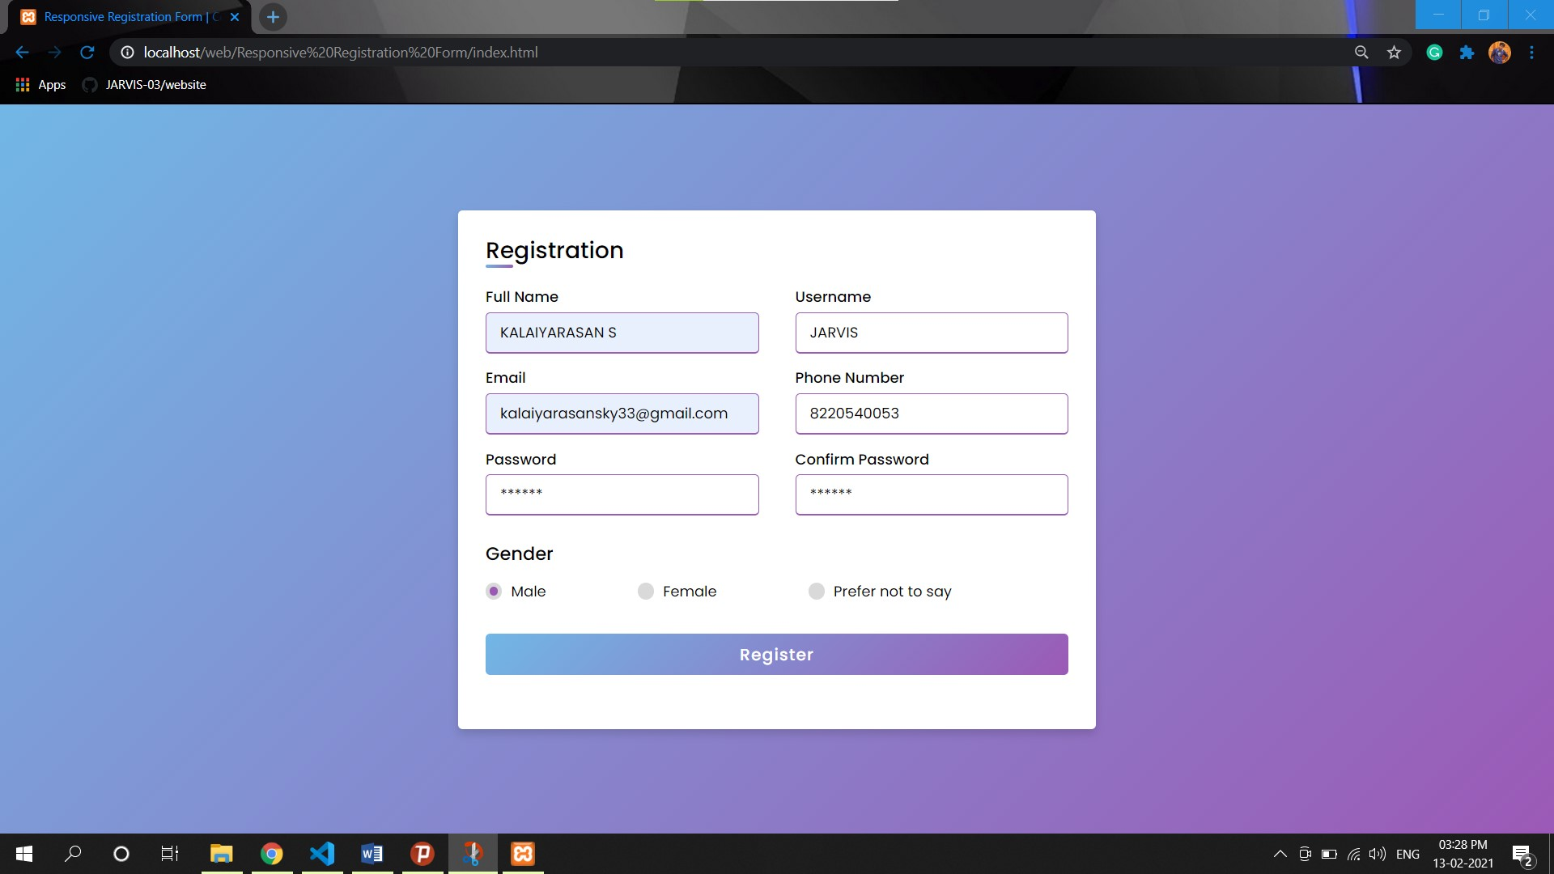

Registration Page Code:
<!DOCTYPE html>
<html lang="en" dir="ltr">
<head>
<meta charset="UTF-8">
<title> CREATE ACCOUNT | SKY INDUSTRIES</title>
<link rel="stylesheet" href="style.css">
<meta name="viewport" content="width=device-width, initial-scale=1.0">
</head>
<body>
<div class="container">
<div class="title">Registration</div>
<div class="content">
<form action="connect.php" method="POST">
<div class="user-details">
<div class="input-box">
<span class="details">Full Name</span>
<input type="text" placeholder="Enter your name" name="fullname">
</div>
<div class="input-box">
<span class="details">Username</span>
<input type="text" placeholder="Enter your username" name="username">
</div>
<div class="input-box">
<span class="details">Email</span>
<input type="text" placeholder="Enter your email" name="email">
</div>
<div class="input-box">
<span class="details">Phone Number</span>
<input type="text" placeholder="Enter your number" name="number" >
</div>
<div class="input-box">
<span class="details">Password</span>
<input type="text" placeholder="Enter your password" name="password">
</div>
<div class="input-box">
<span class="details">Confirm Password</span>
<input type="text" placeholder="Confirm your password" name="cpassword" >
</div>
</div>
<div class="gender-details">
<input type="radio" name="gender" id="dot-1" >
<input type="radio" name="gender" id="dot-2" >
<input type="radio" name="gender" id="dot-3" >
<span class="gender-title" name="gender">Gender</span>
<div class="category">
<label for="dot-1">
<span class="dot one"></span>
<span class="gender" value="m">Male</span>
</label>
<label for="dot-2">
<span class="dot two"></span>
<span class="gender" value="f">Female</span>
</label>
<label for="dot-3">
<span class="dot three"></span>
<span class="gender" value="o">Prefer not to say</span>
</label>
</div>
</div>
<div class="button">
<input type="submit" value="Register">
</div>
</form>
</div>
</div>

</body>
</html>

Log In Page:

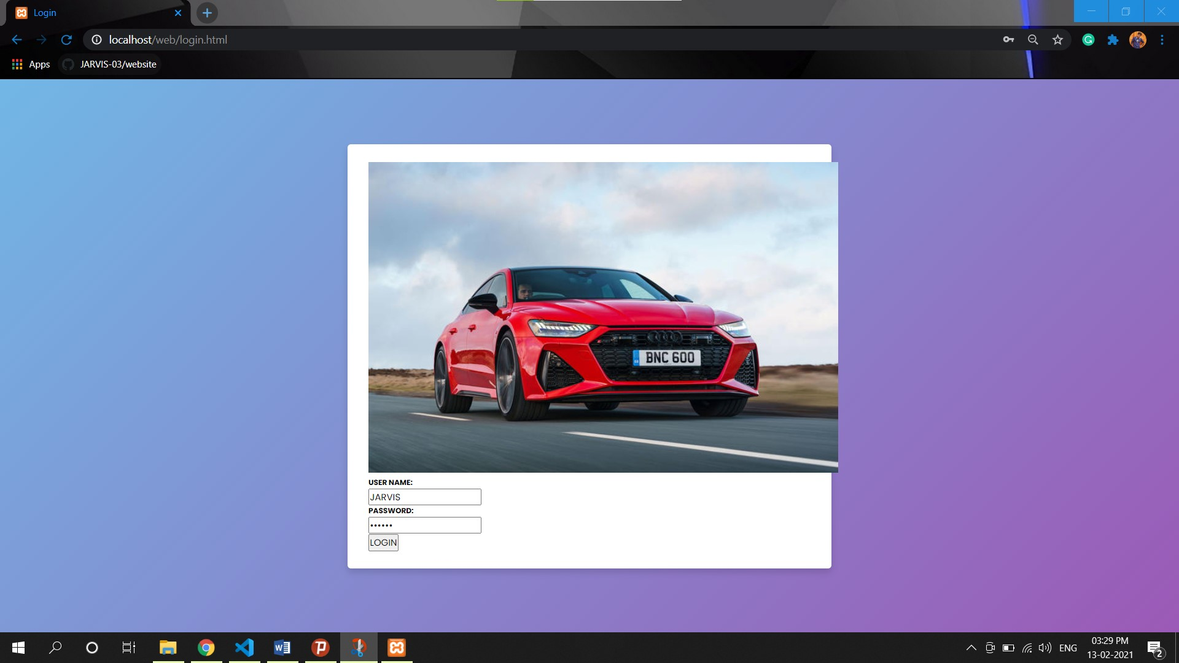

Log In Page Code:
<!DOCTYPE html>
<html>
<head>
<title> Login</title>
<link rel="stylesheet" a href="\web\Responsive Registration Form\style.css">
<link rel="stylesheet" a href="\web\Responsive Registration Form\style.css">
</head>
<body>
<div class="container">
<img src="images/banner4.jpg"/>
<p><h6 >USER NAME:</h6></p>
<form method="POST" action="login.php">
<div class="form-input">
<input type="text" name="username" placeholder="Enter the User Name"/>
</div>
<p><h6 >PASSWORD:</h6></p>
<div class="form-input">
<input type="password" name="password" placeholder="password"/>
</div>
<input type="submit" value="LOGIN" class="btn-login"/>
</form>
</div>
</body>
PHP Database Code (Registration):
<?php
$fullname = $_POST['fullname'];
$username = $_POST['username'];
$gender = $_POST['gender'];
$email = $_POST['email'];
$password = $_POST['password'];
$cpassword = $_POST['cpassword'];
$number = $_POST['number'];

// Database connection
$conn = new mysqli('localhost','root','','test');
if($conn->connect_error){
echo "$conn->connect_error";
die("Connection Failed : ". $conn->connect_error);
} else {
$stmt = $conn->prepare("insert into registration(fullname, username, gender, email, password, cpassword, number) values(?, ?, ?, ?, ?, ?, ?)");
$stmt->bind_param("ssssssi", $fullname, $username, $gender, $email, $password, $cpassword, $number);
$execval = $stmt->execute();
echo $execval;
echo "Registration successfully...";
$stmt->close();
$conn->close();
}
?>

PHP Database Code (Log In):
<?php

$host="localhost";
$user="root";
$password="";
$db="test";

$conn = new mysqli('localhost','root','','test');
if(isset($_POST['username'])){

$username=$_POST['username'];
$password=$_POST['password'];

$sql="select * from registration where user='".$username."'AND Pass='".$password."' limit 1";

$result=mysql_query($sql, $conn );

if(mysql_num_rows($result)==1){
echo " You Have Successfully Logged in";

}
else{
echo " You Have Entered Incorrect Password";

}

}
?>

CSS Code (Log In):
body{
margin: 0 auto;
background-image: url("../image/technology.jpg");
background-repeat: no-repeat;
background-size: 100% 720px;
}

.container{
width: 500px;
height: 450px;
text-align: center;
margin: 0 auto;
background-color: rgba(44, 62, 80,0.7);
margin-top: 160px;
}

.container img{
width: 150px;
height: 150px;
margin-top: -60px;
}

input[type="text"],input[type="password"]{
margin-top: 30px;
height: 45px;
width: 300px;
font-size: 18px;
margin-bottom: 20px;
background-color: #fff;
padding-left: 40px;
}

.form-input::before{
content: "\f007";
font-family: "FontAwesome";
padding-left: 07px;
padding-top: 40px;
position: absolute;
font-size: 35px;
color: #2980b9;
}

.form-input:nth-child(2)::before{
content: "\f023";
}

.btn-login{
padding: 15px 25px;
border: none;
background-color: #27ae60;
color: #fff;
}

PHP Database Code (Contact):

<?php
$userName = $_POST['userName'];
$userEmail = $_POST['userEmail'];
$userPhone = $_POST['userPhone'];
$userMsg = $_POST['userMsg'];

// Database connection
$conn = new mysqli('localhost','root','','test');
if($conn->connect_error){
echo "$conn->connect_error";
die("Connection Failed : ". $conn->connect_error);
} else {
$stmt = $conn->prepare("insert into contact(userName, userEmail, userPhone, userMsg) values(?, ?, ?, ?)");
$stmt->bind_param("ssis", $userName, $userEmail, $userPhone, $userMsg);
$execval = $stmt->execute();
echo $execval;
echo "Request Submitted successfully...";
$stmt->close();
$conn->close();
}
?>

Java Script Code (Script):
$(window).load(function(){

// We are listening to the window.load event, so we can be sure
// that the images in the slideshow are loaded properly.

// Testing wether the current browser supports the canvas element:
var supportCanvas = 'getContext' in document.createElement('canvas');

// The canvas manipulations of the images are CPU intensive,
// this is why we are using setTimeout to make them asynchronous
// and improve the responsiveness of the page.

var slides = $('#slideshow li'),
current = 0,
slideshow = {width:0,height:0};

setTimeout(function(){

window.console && window.console.time && console.time('Generated In');

if(supportCanvas){
$('#slideshow img').each(function(){

if(!slideshow.width){
// Taking the dimensions of the first image:
slideshow.width = this.width;
slideshow.height = this.height;
}

// Rendering the modified versions of the images:
createCanvasOverlay(this);
});
}

window.console && window.console.timeEnd && console.timeEnd('Generated In');

$('#slideshow .arrow').click(function(){
var li = slides.eq(current),
canvas = li.find('canvas'),
nextIndex = 0;

// Depending on whether this is the next or previous
// arrow, calculate the index of the next slide accordingly.

if($(this).hasClass('next')){
nextIndex = current >= slides.length-1 ? 0 : current+1;
}
else {
nextIndex = current <= 0 ? slides.length-1 : current-1;
}

var next = slides.eq(nextIndex);

if(supportCanvas){

// This browser supports canvas, fade it into view:

canvas.fadeIn(function(){

// Show the next slide below the current one:
next.show();
current = nextIndex;

// Fade the current slide out of view:
li.fadeOut(function(){
li.removeClass('slideActive');
canvas.hide();
next.addClass('slideActive');
});
});
}
else {

// This browser does not support canvas.
// Use the plain version of the slideshow.

current=nextIndex;
next.addClass('slideActive').show();
li.removeClass('slideActive').hide();
}
});

},100);

// This function takes an image and renders
// a version of it similar to the Overlay blending
// mode in Photoshop.

function createCanvasOverlay(image){

var canvas = document.createElement('canvas'),
canvasContext = canvas.getContext("2d");

// Make it the same size as the image
canvas.width = slideshow.width;
canvas.height = slideshow.height;

// Drawing the default version of the image on the canvas:
canvasContext.drawImage(image,0,0);

// Taking the image data and storing it in the imageData array:
var imageData = canvasContext.getImageData(0,0,canvas.width,canvas.height),
data = imageData.data;

// Loop through all the pixels in the imageData array, and modify
// the red, green, and blue color values.

for(var i = 0,z=data.length;i<z;i++){

// The values for red, green and blue are consecutive elements
// in the imageData array. We modify the three of them at once:

data[i] = ((data[i] < 128) ? (2*data[i]*data[i] / 255) : (255 - 2 * (255 - data[i]) * (255 - data[i]) / 255));
data[++i] = ((data[i] < 128) ? (2*data[i]*data[i] / 255) : (255 - 2 * (255 - data[i]) * (255 - data[i]) / 255));
data[++i] = ((data[i] < 128) ? (2*data[i]*data[i] / 255) : (255 - 2 * (255 - data[i]) * (255 - data[i]) / 255));

// After the RGB elements is the alpha value, but we leave it the same.
++i;
}
// Putting the modified imageData back to the canvas.
canvasContext.putImageData(imageData,0,0);
// Inserting the canvas in the DOM, before the image:
image.parentNode.insertBefore(canvas,image);
}
});

Java Script Code (superfish):
;(function($){
$.fn.superfish = function(op){

var sf = $.fn.superfish,
c = sf.c,
$arrow = $(['<span class="',c.arrowClass,'"> &#187;</span>'].join('')),
over = function(){
var $$ = $(this), menu = getMenu($$);
clearTimeout(menu.sfTimer);
$$.showSuperfishUl().siblings().hideSuperfishUl();
},
out = function(){
var $$ = $(this), menu = getMenu($$), o = sf.op;
clearTimeout(menu.sfTimer);
menu.sfTimer=setTimeout(function(){
o.retainPath=($.inArray($$[0],o.$path)>-1);
$$.hideSuperfishUl();
if (o.$path.length && $$.parents(['li.',o.hoverClass].join('')).length<1){over.call(o.$path);}
},o.delay);
},
getMenu = function($menu){
var menu = $menu.parents(['ul.',c.menuClass,':first'].join(''))[0];
sf.op = sf.o[menu.serial];
return menu;
},
addArrow = function($a){ $a.addClass(c.anchorClass).append($arrow.clone()); };

return this.each(function() {
var s = this.serial = sf.o.length;
var o = $.extend({},sf.defaults,op);
o.$path = $('li.'+o.pathClass,this).slice(0,o.pathLevels).each(function(){
$(this).addClass([o.hoverClass,c.bcClass].join(' '))
.filter('li:has(ul)').removeClass(o.pathClass);
});
sf.o[s] = sf.op = o;

$('li:has(ul)',this)[($.fn.hoverIntent && !o.disableHI) ? 'hoverIntent' : 'hover'](over,out).each(function() {
if (o.autoArrows) addArrow( $('>a:first-child',this) );
})
.not('.'+c.bcClass)
.hideSuperfishUl();

var $a = $('a',this);
$a.each(function(i){
var $li = $a.eq(i).parents('li');
});
o.onInit.call(this);

}).each(function() {
var menuClasses = [c.menuClass];
if (sf.op.dropShadows && !($.browser.msie && $.browser.version < 7)) menuClasses.push(c.shadowClass);
$(this).addClass(menuClasses.join(' '));
});
};

var sf = $.fn.superfish;
sf.o = [];
sf.op = {};
sf.IE7fix = function(){
var o = sf.op;
if ($.browser.msie && $.browser.version > 6 && o.dropShadows && o.animation.opacity!=undefined)
this.toggleClass(sf.c.shadowClass+'-off');
};
sf.c = {
bcClass : 'sf-breadcrumb',
menuClass : 'sf-js-enabled',
anchorClass : 'sf-with-ul',
arrowClass : 'sf-sub-indicator',
shadowClass : 'sf-shadow'
};
sf.defaults = {
hoverClass : 'sfHover',
pathClass : 'overideThisToUse',
pathLevels : 2,
delay : 1000,
animation : {height:'show'},
speed : 'normal',
autoArrows : false,
dropShadows : false,
disableHI : false, // true disables hoverIntent detection
onInit : function(){}, // callback functions
onBeforeShow: function(){},
onShow : function(){},
onHide : function(){}
};
$.fn.extend({
hideSuperfishUl : function(){
var o = sf.op,
not = (o.retainPath===true) ? o.$path : '';
o.retainPath = false;
var $ul = $(['li.',o.hoverClass].join(''),this).add(this).not(not).removeClass(o.hoverClass)
.find('>ul').hide();
o.onHide.call($ul);
return this;
},
showSuperfishUl : function(){
var o = sf.op,
sh = sf.c.shadowClass+'-off',
$ul = this.addClass(o.hoverClass)
.find('>ul:hidden');
sf.IE7fix.call($ul);
o.onBeforeShow.call($ul);
$ul.animate(o.animation,o.speed,function(){ sf.IE7fix.call($ul); o.onShow.call($ul); });
return this;
}
});

})(jQuery);
/*---------------------*/
$(function(){
$('.sf-menu').superfish({speed:'fast'});
})

CSS Code (Registeration):
@import url('https://fonts.googleapis.com/css2?family=Poppins:wght@200;300;400;500;600;700&display=swap');
*{
margin: 0;
padding: 0;
box-sizing: border-box;
font-family: 'Poppins',sans-serif;
}
body{
height: 100vh;
display: flex;
justify-content: center;
align-items: center;
padding: 10px;
background: linear-gradient(135deg, #71b7e6, #9b59b6);
}
.container{
max-width: 700px;
width: 100%;
background-color: #fff;
padding: 25px 30px;
border-radius: 5px;
box-shadow: 0 5px 10px rgba(0,0,0,0.15);
}
.container .title{
font-size: 25px;
font-weight: 500;
position: relative;
}
.container .title::before{
content: "";
position: absolute;
left: 0;
bottom: 0;
height: 3px;
width: 30px;
border-radius: 5px;
background: linear-gradient(135deg, #71b7e6, #9b59b6);
}
.content form .user-details{
display: flex;
flex-wrap: wrap;
justify-content: space-between;
margin: 20px 0 12px 0;
}
form .user-details .input-box{
margin-bottom: 15px;
width: calc(100% / 2 - 20px);
}
form .input-box span.details{
display: block;
font-weight: 500;
margin-bottom: 5px;
}
.user-details .input-box input{
height: 45px;
width: 100%;
outline: none;
font-size: 16px;
border-radius: 5px;
padding-left: 15px;
border: 1px solid #ccc;
border-bottom-width: 2px;
transition: all 0.3s ease;
}
.user-details .input-box input:focus,
.user-details .input-box input:valid{
border-color: #9b59b6;
}
form .gender-details .gender-title{
font-size: 20px;
font-weight: 500;
}
form .category{
display: flex;
width: 80%;
margin: 14px 0 ;
justify-content: space-between;
}
form .category label{
display: flex;
align-items: center;
cursor: pointer;
}
form .category label .dot{
height: 18px;
width: 18px;
border-radius: 50%;
margin-right: 10px;
background: #d9d9d9;
border: 5px solid transparent;
transition: all 0.3s ease;
}
#dot-1:checked ~ .category label .one,
#dot-2:checked ~ .category label .two,
#dot-3:checked ~ .category label .three{
background: #9b59b6;
border-color: #d9d9d9;
}
form input[type="radio"]{
display: none;
}
form .button{
height: 45px;
margin: 35px 0
}
form .button input{
height: 100%;
width: 100%;
border-radius: 5px;
border: none;
color: #fff;
font-size: 18px;
font-weight: 500;
letter-spacing: 1px;
cursor: pointer;
transition: all 0.3s ease;
background: linear-gradient(135deg, #71b7e6, #9b59b6);
}
form .button input:hover{
/* transform: scale(0.99); */
background: linear-gradient(-135deg, #71b7e6, #9b59b6);
}
@media(max-width: 584px){
.container{
max-width: 100%;
}
form .user-details .input-box{
margin-bottom: 15px;
width: 100%;
}
form .category{
width: 100%;
}
.content form .user-details{
max-height: 300px;
overflow-y: scroll;
}
.user-details::-webkit-scrollbar{
width: 5px;
}
}
@media(max-width: 459px){
.container .content .category{
flex-direction: column;
}
}

Conclusion:
Vehicle Management application has rich user interface so that users can access the application easily. This application provides the management reports like Booking status, Occupancy report, Booking charts, Vehicle Rating, Fleet Management, Bill Management and Expenses Management.
Our project is only a humble venture to satisfy the needs in a library. Several user friendly coding have also adopted. This package shall prove to be a powerful package in satisfying all the requirements of the organization.
The objective of software planning is to provide a frame work that enables the manger to make reasonable estimates made within a limited time frame and integration of different applications into one software to reduce the cost implied to purchase software by the company at the beginning of the software project and should be updated regularly as the project progresses. Last but not least it is no the work that played the ways to success but ALMIGHTY.

